URMC Chloride Content After Pavix® CCC 100 Application
Daniel MacEachern, Senior Technical Representative
StructureCare®

While concrete is a strong and robust material, its nemeses are water and water-soluble chemicals. When viewed at a distance, concrete appears to be an impenetrable material, but when viewed under magnification this is not the case. Shrinkage cracks, micro-cracks and air pockets allow soluble corrosive chemicals to absorb within the voids and saturate the concrete matrix. These chemicals will remain within the concrete matrix for the life of the material, accelerating the corrosion process and deteriorating the concrete from within at a faster rate. Moreover, entrapped water conditioned to freeze/thaw cycles further hastens the deterioration process by contributing to additional stresses by means of expansion and contraction. The voids become larger and exacerbate the intrusion of water and corrosive chemicals, eventually reaching the structural reinforcement. Once it saturates around the embedded steel, the metal corrodes, expands and causes further deterioration. The list of problems associated with moisture intrusion in concrete is long and the problems can be catastrophic.
In order to lessen and slow the ramifications mentioned above, StructureCare is launching the use of Pavix® CCC100 as part of its material portfolio. A nontoxic, environmentally safe, organic material that chemically treats concrete; it is both odorless, colorless and applied in one application to saturate the concrete matrix. Some of the material reacts with carbon dioxide at the surface to produce an invisible and insoluble water repellent. Whereas the remainder will fill cracks and voids, rendering them watertight up to a 1/16th of an inch in width.
The product uses both hygroscopic and hydrophilic crystalline molecules. The hygroscopic crystals are attracted to and migrate towards a moisture source; while the hydrophilic crystals swell and absorb water up to 16 times their size, filling the voids within the concrete matrix.
When the Pavix® CCC100 treated concrete is subjected to moisture, the crystals react instantaneously by expanding and pushing back the water towards the water source, “the surface”, rendering the concrete impermeable. The crystals then recede back to their original size once the concrete is dry, allowing it to naturally breath. As the crystals expand and recede throughout the life of the concrete, the water-soluble chemicals dissolve within the matrix and the phenomenon will continue to purge the once entrapped contaminants to the surface, eventually ridding the concrete of the deleterious soluble substances.
Preliminary inhouse testing to validate these claims took place this year at the University of Rochester Medical Center in Rochester, NY. The third-party laboratory testing of the soluble chlorides within extracted samples showed a chloride content within the matrix that was 15 times higher than the ACI threshold. This threshold determines the chloride content at which conventional reinforcement begins to corrode.
After applying the Pavix® CCC100 material and allowing two months for the material to react, additional test samples were extracted adjacent to the original samples. The post product application, tested by the same laboratory, showed a 95% reduction in the chloride content, bringing the level well below the ACI threshold.
The following graphs illustrate pre and post application of the Pavix®CCC100. The area circled on the first graph represents the chloride content of the pre-Pavix® application, followed by the chloride results obtained post application.
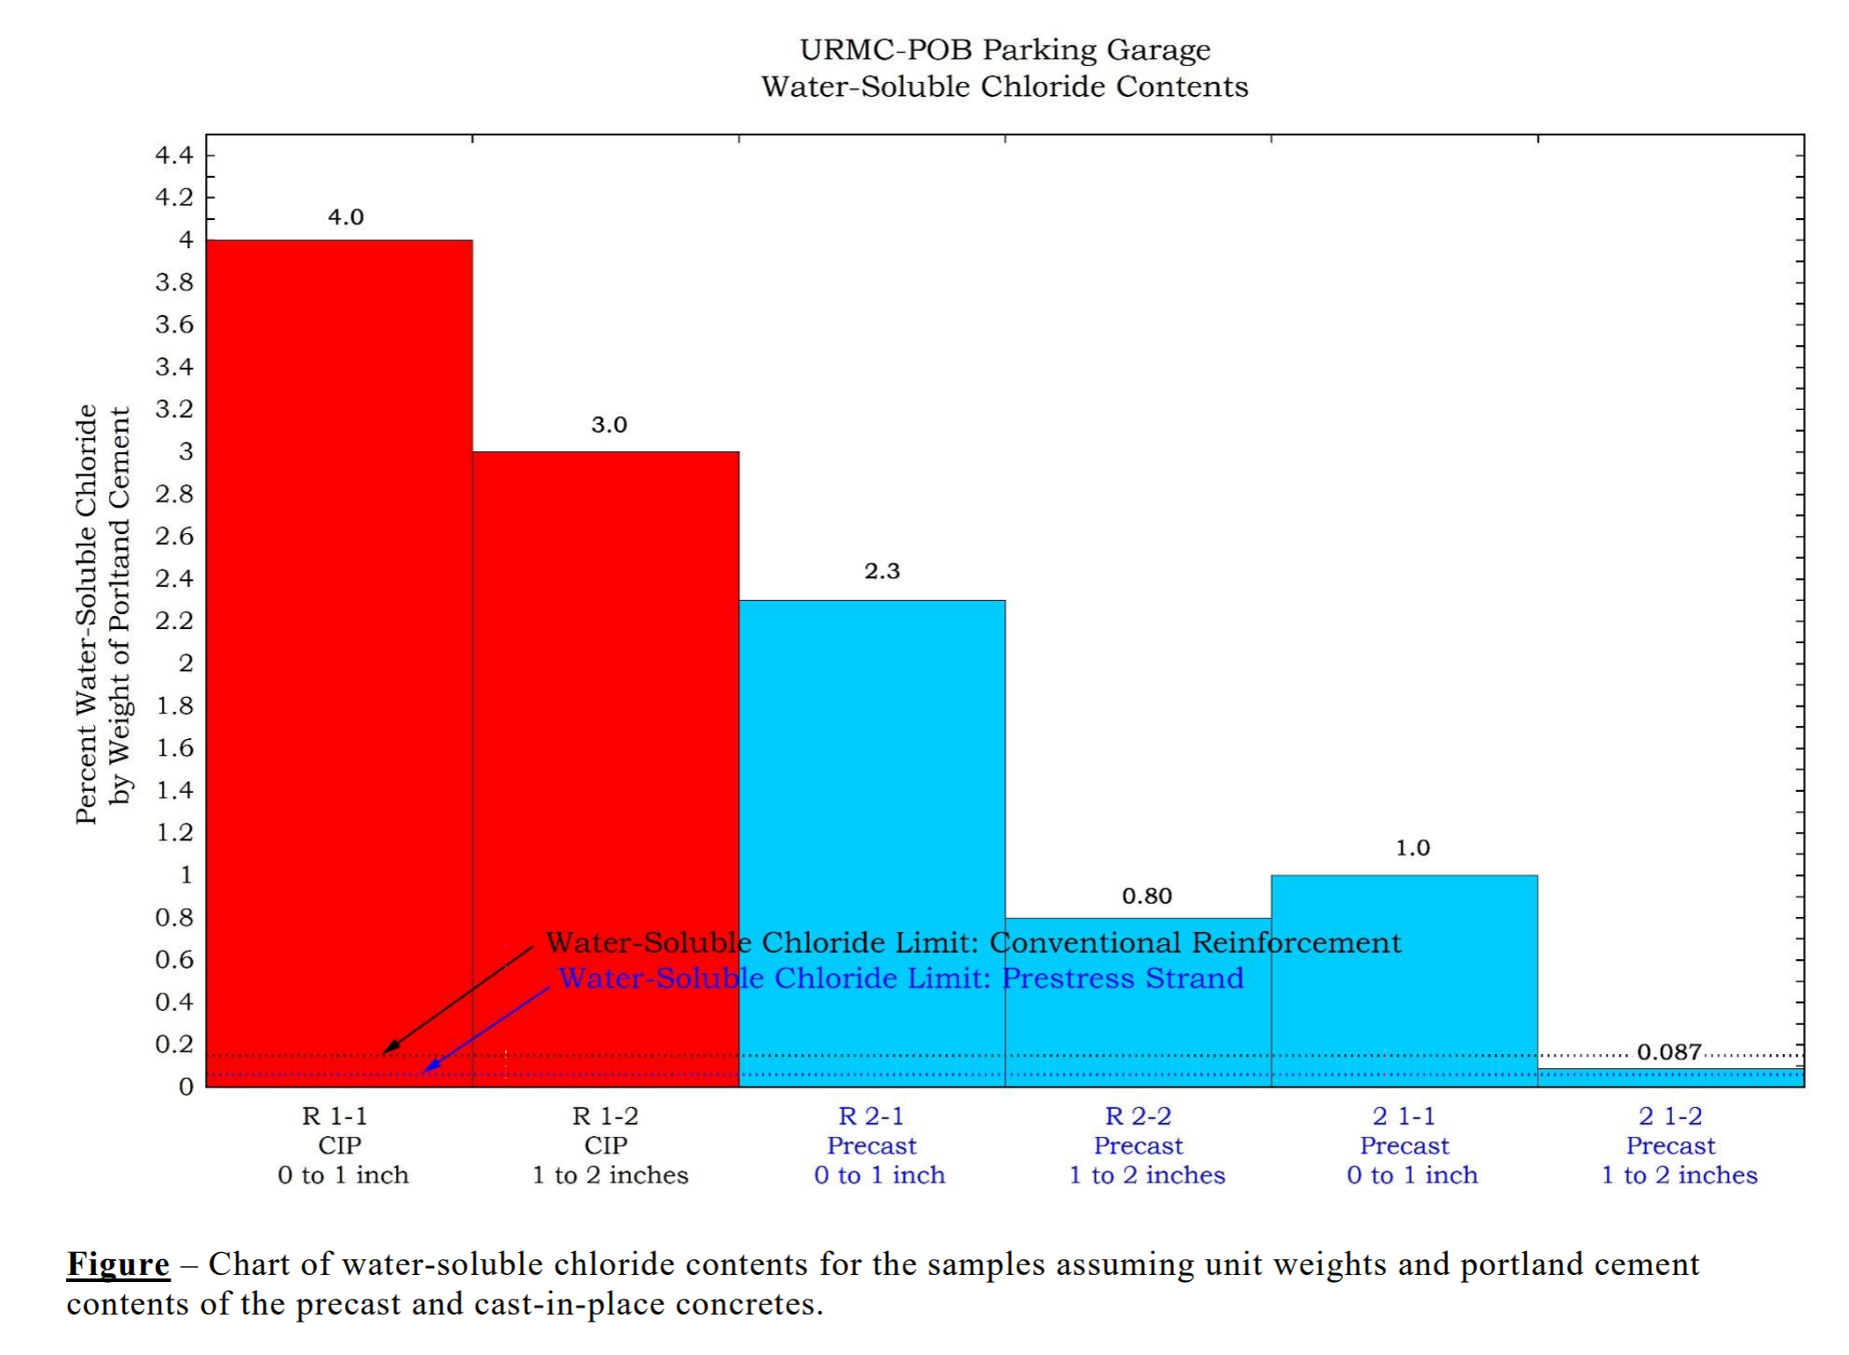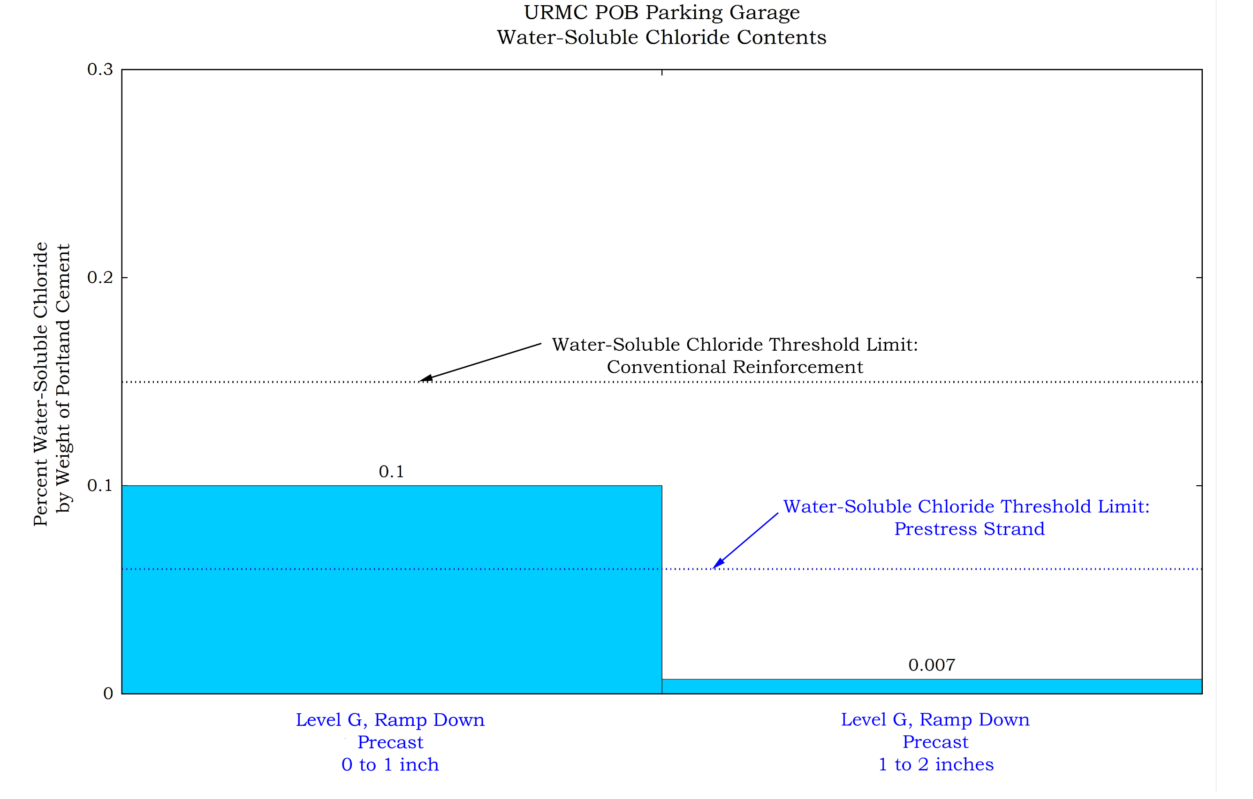
The results look very promising and additional in-situ testing is underway at Lehigh University in Bethlehem, PA and are beginning at the Geisinger Community Medical Center in Scranton, PA. Test results will be available by year’s end to help further substantiate our findings at URMC and the manufacturers claims.

